

**VIRGINIA COMMONWEALTH UNIVERSITY**

**Statistical analysis and modelling (SCMA 632)**

**A5- Visualization - Perceptual Mapping for**

**Business**

**ANJU MARIA PHILIP**

**V01101169**

**Date of Submission: 15-07-2024**

**CONTENTS**

|  |  |  |
| --- | --- | --- |
| **Sl. No.** | **Title** | **Page No.** |
| **1.** | Introduction | **3** |
| **2.** | Objective | **3-4** |
| **3.** | Results | **4-8** |
| **4.** | Interpretations | **8** |
| **5.** | Recommendations | **8-9** |

**INTRODUCTION**

This report presents an analysis of the NSSO68 dataset, focusing on the state of Odisha (ORI). The objective is to examine the distribution of total food consumption across different districts within the state and visualize the consumption patterns district-wise. The dataset comprises various variables such as the quantity of rice, wheat, chicken, pulses, and other food items consumed. In addition, this report includes an imputation of missing values and removal of outliers to ensure the accuracy and reliability of the analysis. The analysis involves plotting a histogram to illustrate the overall distribution of total consumption and a bar plot to highlight the total consumption per district. Furthermore, a geospatial representation of the consumption data on the map of Odisha will be created, providing a visual understanding of the consumption patterns across the state.

**OBJECTIVES**

• **Examine Data Distribution:**

* To analyse and understand the distribution of total food consumption across different districts within the state of Odisha using the NSSO68 dataset.
* To identify the central tendency and variability in the consumption data.

• **Impute Missing Values:**

* To ensure the completeness and accuracy of the dataset by imputing missing values using the mean.
* To handle missing data efficiently, preventing any potential biases in the analysis.

• **Remove Outliers:**

* To identify and remove outliers in key consumption variables to avoid skewed results.
* To ensure that the analysis is based on reliable and consistent data.

• **Calculate Total Consumption:**

* To compute the total food consumption per household by aggregating the quantities of various food items.
* To create a new variable that represents the overall food consumption for further analysis.

• **Summarize Consumption by District:**

* To aggregate and compare total food consumption across different districts within Odisha.
* To identify districts with the highest and lowest levels of food consumption.

• **Visualize Consumption Patterns:**

* To create visual representations such as histograms and bar plots to depict the distribution of total consumption and district-wise consumption patterns.
* To use geospatial mapping techniques to display consumption data on the Odisha state map, providing a clear visual understanding of regional consumption differences.

• **Enhance Data Interpretation:**

* To facilitate easier interpretation and analysis of complex data through visualizations.
* To support decision-making processes related to food distribution, resource allocation, and policy planning based on the consumption patterns observed in the dataset

**RESULTS**

**USING PYTHON**

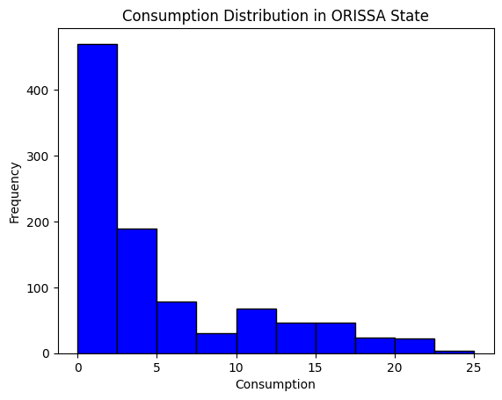

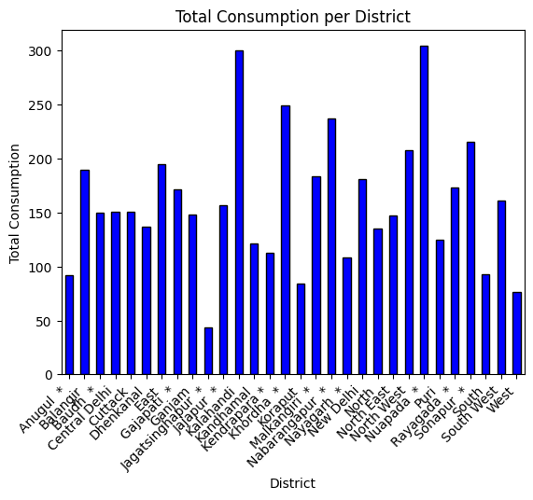

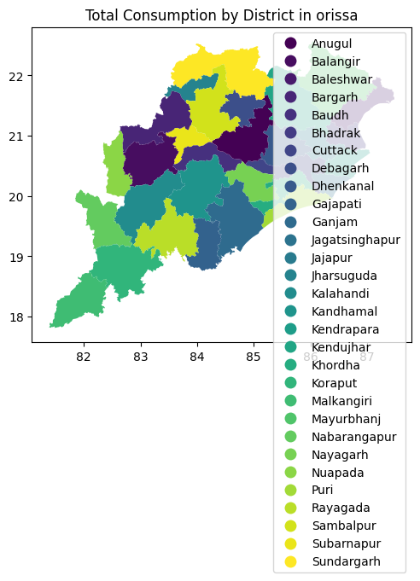

**USING R**

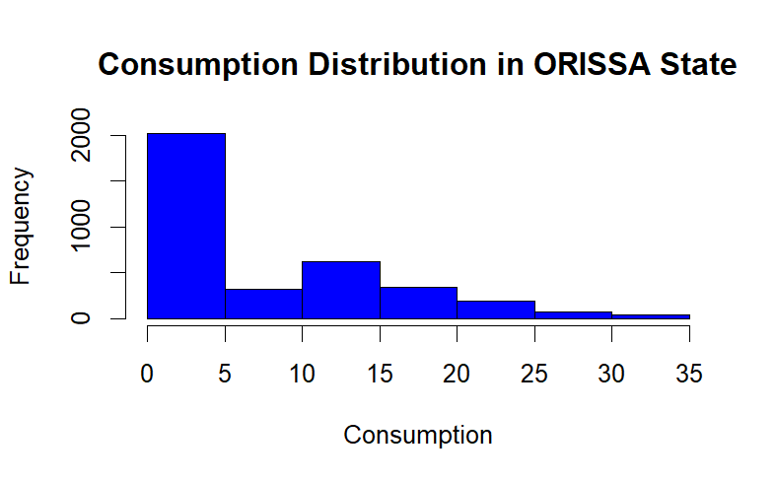

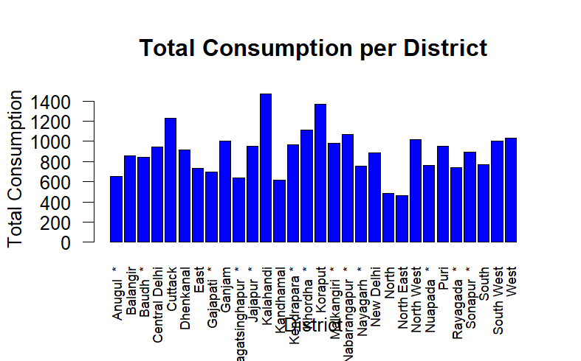

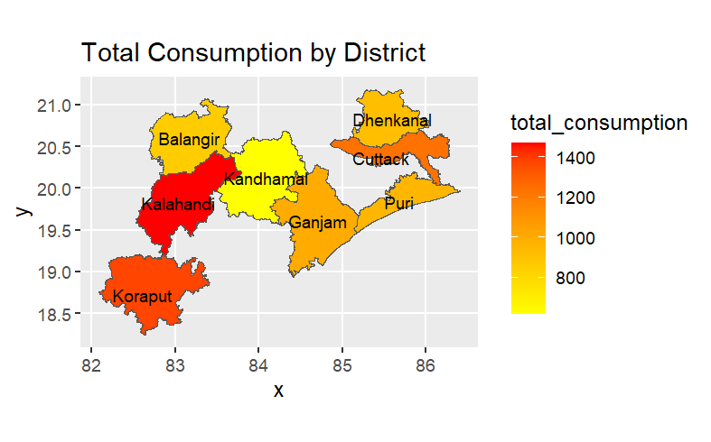

**INTERPRETATION**

The visual analysis of the NSSO68 dataset for the state of Odisha reveals significant insights into the distribution of total food consumption across its districts. The histogram illustrates a highly skewed distribution, with a majority of households having lower total consumption levels, indicating that most households consume relatively fewer quantities of food items included in the dataset. This pattern suggests the presence of widespread lower consumption levels, possibly due to economic constraints or other factors affecting food accessibility and affordability. The bar plot highlights the district-wise consumption, where each district is represented by different colour intensities on the map of Odisha, showcasing the geographical variation in total consumption. Districts such as Anugul and Balangir display moderate consumption levels, whereas other districts show varying degrees of consumption, with some having notably lower levels. This geographical representation provides a clear visual understanding of how food consumption is distributed across the state, aiding in identifying areas that may require targeted interventions to improve food security and distribution.

**RECOMENTATION**

The visualizations indicate a significant variation in total consumption across different districts in Odisha. The district-wise map shows that consumption is concentrated in specific regions, with some districts displaying much higher consumption than others. The histogram reveals a skewed distribution with a majority of districts having lower consumption values and a few districts with very high consumption. The bar plot further highlights the disparity in consumption, showing notable peaks in districts like Khordha, Kalahandi, and Ganjam. Given this data, it is recommended that resource allocation and development initiatives should be targeted towards districts with lower consumption to promote balanced regional development and ensure equitable distribution of resources. This approach will help in uplifting the overall socio-economic status of the under-consuming districts while maintaining the growth momentum in the high-consuming areas. Additionally, fostering local industries and encouraging sustainable agricultural practices can help boost the economic activity in these areas. Regular monitoring and evaluation of these initiatives will be crucial to measure progress and make necessary adjustments. By focusing on these strategies, the state can work towards reducing regional disparities and improving the overall quality of life for its residents.